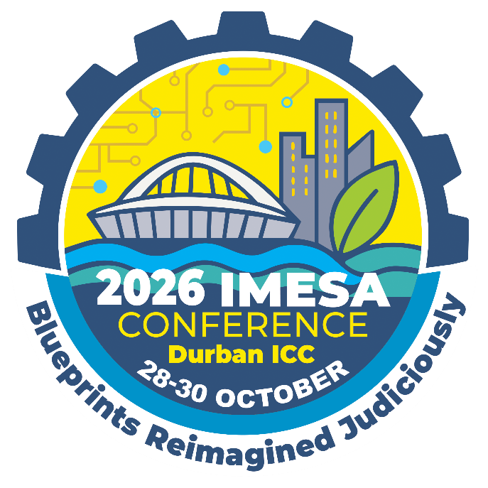

CALL FOR
ABSTRACTS

DEADLINE FOR SUBMISSIONS
10 APRIL 2026

IMESA is calling for Abstracts for consideration for the 89th IMESA Conference & Exhibition that will be held at the Durban International Convention Centre (ICC) from 28-30 October 2026.

The theme of the Conference is “Blueprints Reimagined Judiciously”.

Main themes of the conference are focused but not limited to the following: -

- Buildings, Structures & Housing
- Ecological, Environmental & Social
- Electrical & Electronic
- Financial, Legal & Regulatory
- Transport, Roads & Stormwater
- Water & Sanitation

The title and topic of presentations will be evaluated for innovation, thought, leadership, business value and interest and conformance to the Conference theme. Only the best will be selected to go to the next phase.

THE PROCESS
Participants are required to go through a review process called the Call for Papers process. All stages of the process are reviewed by a Technical Advisory Committee (TAC). The process has 3 Phases:-

PHASE 1  SUBMISSION of ABSTRACTS | PHASE 2  SUBMISSION of FULL PAPER | PHASE 3  SUBMISSION of PRESENTATION
Deadline – 10 April 2026  AFTER REVIEW – Participants will be notified if they will be moving to Phase 2. | Deadline communicated & applicable ONLY to successful participants of Phase 1.  AFTER REVIEW – Participants will be notified if they will be moving to PHASE 3. | Deadline communicated & applicable ONLY to successful participants of Phase 2.  Participants completing this Phase will be Presenting at Conference.
Completed submissions to be forwarded to Melanie Stemmer at marketing@imesa.org.za

IMPORTANT TO NOTE :
All CONFIRMED Speakers / Presenters will be fee-paying delegates qualifying for a special reduced rate. Keep this in mind when submitting your abstract for consideration. For more information contact Melanie Stemmer on marketing@imesa.org.za or 031 266 3263.

 | Photo: |  |  |  | 
NAME(S) & SURNAME: | Click or tap here to enter text.
ORGANISATION: | Click or tap here to enter text.
CONTACT DETAILS: | TEL: | Click or tap here to enter text.
CONTACT DETAILS: | CELL: | Click or tap here to enter text.
CONTACT DETAILS: | EMAIL: | Click or tap here to enter text.
SPEAKER RESUME- 200 words maximum
* NOTE: Key points to include are the following:
Qualifications / Current position and past experience / Any seats held on various engineering boards. Any research you might have done / Any relevant additional information
Click or tap here to enter text.
ADDITIONAL PRESENTER - Complete ONLY if there will be an ADDITIONAL PRESENTER
NAME(S) & SURNAME: | Click or tap here to enter text.
ORGANISATION: | Click or tap here to enter text.
CONTACT DETAILS: | CELL: | Click or tap here to enter text. | E-MAIL: | Click or tap here to enter text.
PRESENTERS PROFILE: | Click or tap here to enter text.

ORM

DETAILS OF SUBMISSION - Indicate what you want your abstract to be considered for
CATEGORY OF SUBMISSION: | ☐ | Buildings, Structures and Housing
CATEGORY OF SUBMISSION: | ☐ | Ecological, Environmental and Social
CATEGORY OF SUBMISSION: | ☐ | Electrical and Electronic
CATEGORY OF SUBMISSION: | ☐ | Financial, Legal and Regulatory
CATEGORY OF SUBMISSION: | ☐ | Transport, Roads and Stormwater
CATEGORY OF SUBMISSION: | ☐ | Water and Sanitation
TITLE OF PROPOSED PRESENTATION: | Click or tap here to enter text.
ABSTRACT - 300 to 350 words
* NOTE: Take caution of word count as you could be marked down should you exceed required word limit
Click or tap here to enter text.
KEY PRESENTATION IMPACT POINTS: | Click or tap here to enter text.

Completed submissions IN WORD FORMAT to be forwarded to
Melanie Stemmer on marketing@imesa.org.za

